TRADEZ
Ana Arellano Beltran
CST-451 Capstone Project Proposal
Grand Canyon University
Instructor: Professor Amr Elchouemi

Revision: 2
Date: 9 / 21 / 25

ABSTRACT
Tradez is a community driven mobile and web application designed to simplify and modernize the old practice of bartering. The platform would allow users to facilitate the exchange of goods and services without the need for money, fostering a more sustainable local economy. By integrating geolocation services, Tradez enables the users to connect with other traders nearby in the community, making local bartering more efficient. Additionally, for those users who prefer online interactions or more choices, an online section allows for remote trades, expanding the potential networks.
The main task of the project was to develop a user-friendly marketplace that promotes community without the need for monetary exchange. Some key features that will be included are user profiles, item listings with images, descriptions, category filters, chat functionality, and a rating system to ensure reliability and transparency. The interface will be built with a focus on navigation, modern design, and smooth performance across devices. Backend will be implemented to manage authentication, data storage, and location-based searches efficiently.

Tradez accomplishes the goal of bringing traditional barter systems with modern digital tools. It will empower those in the community to exchange without financial constraints and help others. It will reduce waste through item reuse and encourage community interaction. Tradez represents a meaningful step toward a more circular and connected economy, one where people trade not just goods but trust and mutual benefit.

History and Signoff Sheet
Change Record
Date | Author | Revision Notes
9/21/25 | Ana Arellano | Initial draft for review/discussion
10/6/25 | Ana Arellano | Changes Based on Feedback
4/10/26 | Ana Arellano | Updated each section necessary

Overall Instructor Feedback/Comments

Overall Instructor Feedback/Comments
Integrated Instructor Feedback into Project Documentation
☐ Yes ☐ No
Project Approval
☐ Professor Amr Elchouemi

TABLE OF CONTENTS
Project Overview and Project Objectives 5
Project Scope 8
Project Success Measures 9
Project High-Level Solution 10
Project Controls 14
Project Cost and Schedule 16
Appendix A – References 17
Appendix B – Copyright Compliance Error! Bookmark not defined.

Project Overview and Project Objectives
State the Problem and Background
Traditionally, many marketplaces and service platforms require the exchange of money, which can limit the accessibility for people who do not have spare money but do have useful services or goods to offer. This creates a block for people who want to trade service for service without the necessity of relying on money. Bartering has existed for centuries, but in this modern time it is less common due to the monetary value now attached to every item. We do not have as many accessible spaces for those who wish to participate in such trades. Most popular platforms now involve transitional fees, have money as an intermediary, or are not designed to encourage fair trade between individuals.
This app would be developed to undertake and address the gap in these platforms and develop an application that would make bartering easy, transparent, and organized. The proposed application would allow users to post services or goods they are willing to trade and specify what they are seeking in return. For example, a user would like to trade guitar lessons for a party planner to plan his 13-year-olds party. By creating a structured marketplace for bartering, the application aims to empower users to maximize the value of their goods and skills, build community connections, and reduce the dependence on monetary exchanges.
This idea was inspired by the hardships that families face during times of need, where strong community support can help prevent difficult situations, including food insecurity. Providing a platform where individuals can barter skills or items can be critical in these circumstances. No one should feel that essential goods or services are inaccessible simply because of financial limitations. By facilitating fair and transparent exchanges, this project aims to empower communities to support one another and meet needs without relying solely on money.

Christian Worldview
From the lens of a Christian worldview, this project connects particularly with the values of community, stewardship, and generosity. The Bible emphasizes the importance of helping others and sharing resources, ensuring that everyone’s needs are met within the community as an expression of faith. Luke 6:38 reminds us, “Give, and it will be given to you,” which reflects the idea that when we give generously we also receive abundance. This principle closely resembles bartering, where individuals exchange goods or services out of generosity and mutual support. The proposed application embodies this principle by creating an online platform where individuals can rely on their community without the stress of financial barriers.

Ethically, the Christian worldview calls for honesty and fairness in all dealings. Ephesians 4:25 states, “Therefore each of you must put off falsehood and speak truthfully to your neighbor, for we are all members of one body.” This principle applies directly to bartering. The application will emphasize transparency and fairness as a core requirement, providing tools that encourage users to approach exchanges with integrity and moral responsibility.

Spiritually, the project supports the biblical command to “love your neighbor as yourself” (Mark 12:31). By encouraging users to value the skills, talents, and resources of others, the platform fosters mutual respect and stronger communities. In this way, the application does not only provide practical value but also reflects the Christian calling to serve others with generosity and compassion.

Approaching this project from a Christian worldview has helped shape its design and purpose. Rather than being driven by profit or monetary gain, the project is guided by Christian principles such as fairness, stewardship, and service. This perspective ensures the development of an application that thrives on the contributions of a supportive and engaged community.

Project Objectives
List objectives that will be used to measure project success.
- User Profiles and Registrations
- Trade Match Filter System
- Transparent Exchange
- User-Experience and Scalability
- Community Trust and Interaction
- Security and Privacy
- Safety and Moderation

Challenges
List the known challenges that will be used to measure project success.
- User Trust and Safety
- Ensuring Fair and Transparent Trades
- System Security and Data Privacy
- Community Engagement
- Geolocation
- Scalability Design
- Responsive Design

Benefits and Opportunities
Describe the benefits or opportunities resulting from project implementation.
Provide references as necessary.
- Making Bartering easier/ Cost Saving
  - With this application users would be able to exchange goods and services without relying on money, making more services and items accessible for those who are limited financially. Instead of spending money on guitar lessons you can make a cake and trade it for a few lessons.
- Promoting Community
  - With this application we can connect users with their community and gain a stronger bond with this exchange of goods. It can foster stronger relationships online and locally, with engagement we can encourage mutual trust and support.
- Encourages Skill Development
  - With this application we provide more accessibility to receive services such as lessons, workshops, or mentoring. This encourages personal growth and knowledge exchange within the community.
- Sustainability
  - With this app we promote the exchange between goods rather than purchasing new items, promoting sustainability and reducing waste. This can be beneficial to our environment and reduce the impact we make on our planet.

NOTE: If necessary, you may add subsections to those listed in order to match the requirements in the assignment description. Do not remove any top-level sections (those that are listed in the Table of Contents).

Project Scope
- Give a clear, concise statement that states the scope of the project. This should also include items that are to be out of scope.
  - Tradez will be a web application that enables users to barter goods and services with their community and as an online marketplace. The app will have a functional interface for posting and browsing trade listings, it will integrate geolocation features for nearby trades. It will have secure use authentication, implementing messaging in the app for communication between traders and have a rating system to promote trust and accountability between users. The app will also include basic admin controls for managing the user’s activity and give users the ability to report content or users.
  - Out of scope for this project would be for some of the online sections in the app. If there were to be a physical trade between online users, there would be logistics of delivery or shipping. The concept of user authentication based on location, like sending a specific code to a user address to verify they are in the community, would also be out of scope.
- Use the template to list all known stakeholders and contacts, if applicable, including self (for some projects self may be the only name listed)
Stakeholder Name | Role(s) | Responsibilities
Ana Arellano Beltran | Owner | Frontend, Backend, UI/UX Design
- List the work breakdown required to satisfy the project objectives. Identify teams and other resources that may be required to successfully complete the project.

Work Breakdown Structure
ID | Task | Dependencies | Status | Effort Hours | Cost | Start Date | Planned Completion | Estimate to Completion | Actual Completion | Resource
1 | Project Planning and Proposal | N/A | Complete | 6 | $0 | 9/15/25 | 9/21/25 | 9/21/25 | 9/22/25 | Capstone Project Handbook
2 | Requirements (Analysis Phase) | N/A | Complete | 8 | $0 | 10/6/25 | 10/12/25 | 10/12/25 | 10/12/25 | Capstone Project Handbook
3 | Final Architectural Plan (Design Phase) | N/A | Complete | 8 | $0 | 11/3/25 | 11/9/25 | 11/9/25 | 11/9/25 | Capstone Project Handbook
4 | Development (Coding Phase) | N/A | Complete | 8 | $0 | 11/17/25 | 11/23/25 | 11/23/25 | 11/23/25 | Capstone Project Handbook
5 | Development and Testing Phase | N/A | Complete | 20 | $0 | 2/15/26 | 3/29/26 | 3/29/26 | 3/29/26 | Capstone Project Handbook
6 | Showcase Poster | N/A | Complete | 2 | $0 | 3/23/26 | 3/29/26 | 3/39/26 | 3/29/26 | Instructor provided instructions
7 | Milestone 6 Final Project Competition | N/A | Complete | 6 | $0 | 3/30/26 | 4/5/26 | 4/5/26 | 4/5/26 | Capstone Project Handbook

Project Success Measures
- Describe what measures will be used to calculate project success.
  - The project success will be determined by evaluating the functionality and user experience if the app. Having the completion and smooth performance of all planned features and the stability of the app across devices. Having the key features of user registration, login, list, and barter items without having technical issues and the overall responsiveness of the app. The effectiveness of the search, filtering, and messaging functions will also be a measure of success. During a bit of testing the feedback and any errors found will be an indicator for success or an indicator for things to refine. The project will be considered successful if it meets all functional requirements, performs reliably, and provides seamless, user-friendly experience for community trading.
- Use the template to list the project completion criteria.
Project Completion Criteria
1 – Core application features work and run smoothly
2 – CRUD with User account
3 – Search and Filtering
4 – Responsive Design
5 – Error Handling
- Use the template to list the project assumptions and constraints, if applicable. An assumption is an educated guess that a likely condition or circumstance is presumed to be true. A constraint is a limiting condition or circumstance that defines the project boundaries. Assumptions allow the project to succeed. Constraints restrict or limit the project execution.
Assumptions and Constraints
ID | Description | Comments | Type | Status | Date Entered
1 | Error Handling and Unknown Factors | With coding handling errors is a given, but some can be more difficult than others. Having to do research on certain features I want to add to my application but don’t know much on is also a given. | Assumption | Potential | 9/22/25
2 | Unknown Life Factors | With life comes unexpected factors that can deter the progress of this project. Whether it is getting sick and having less time to work on the project or something that can cause a bigger impact is always unknown. | Constraint | Potential | 9/22/25
3 | Fairness | With bartering a trade must be fair and worth it for both parties. This can be difficult as fairness can differ between every individual. | Assumption | Potential | 9/22/25
4 | User Safety | Safety is another big factor when bartering as most of those trading are strangers, being able to verify the safety of users is important. | Constraint | Potential | 9/22/25
5 | Unique Features or Design | Although there are not many bartering apps there are many marketplace apps. Having a unique feature or design to stand out can be important. | Assumption | Potential | 9/22/25

Project High-Level Solution
Introduction
Traditional marketplaces often rely solely on monetary transactions, which can be inaccessible to individuals who lack sufficient funds or other means of participating. At the same time, many people possess valuable skills or unused items that go underutilized. This creates a gap where resources are available but remain untapped, while others need them. Tradez aims to bridge this gap by creating a platform for beneficiary exchange allowing people to trade skills and items in a fair, efficient, and accessible way. The project focuses on understanding the resources users have, their willingness to exchange, and the factors that make these interactions trustworthy and appealing
Solution
Tradez is a web application designed to facilitate skill and item exchanges in a digital environment. Built using Java Spring Boot, the platform allows users to list their skills or unused items and browse what others have to offer. The system incorporates features to ensure reliability and fairness, such as user ratings, secure messaging, and structured trade management. Users provide inputs such as profiles, item or skill listings, and trade requests, while outputs include suggested matches, confirmed trades, and user reviews. The backend, built with MySQL, securely stores all user data, trade listings, messages, and reviews in a structured relational database. The system processes data by matching offers with message requests, validating user interactions, and maintaining a trust based on user activity and ratings. By combining a responsive web interface with a Spring Boot backend and MySQL database, Tradez empowers users to maximize the value of their skills and items, making bartering more accessible and appealing than traditional monetary exchanges.

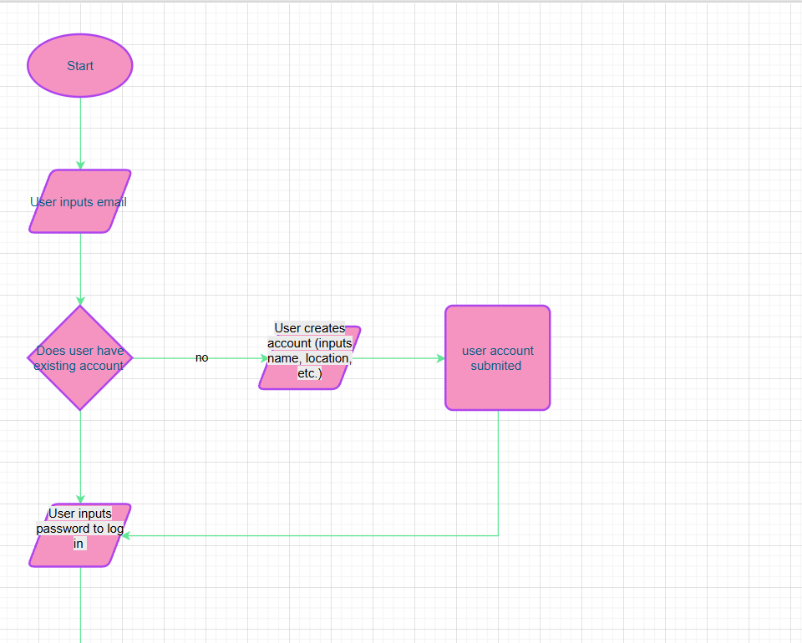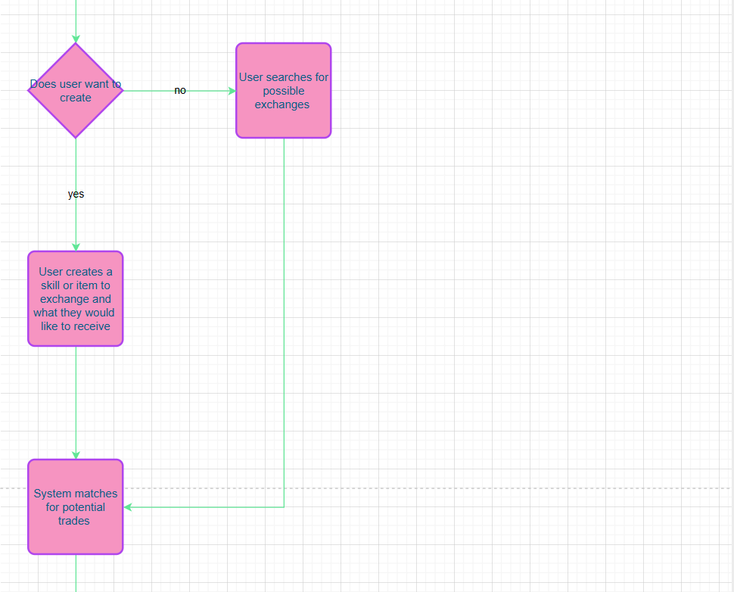
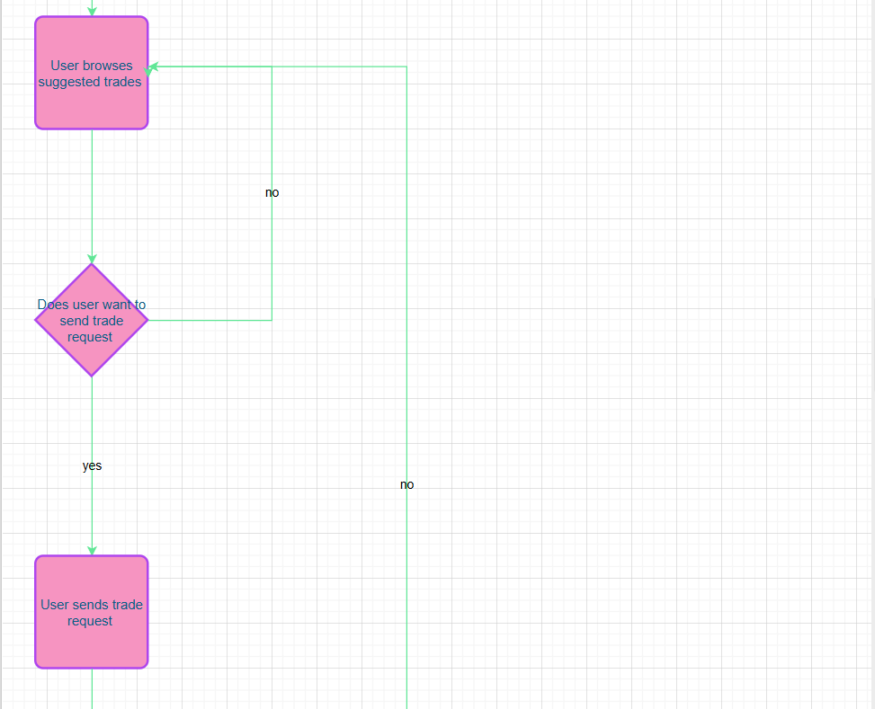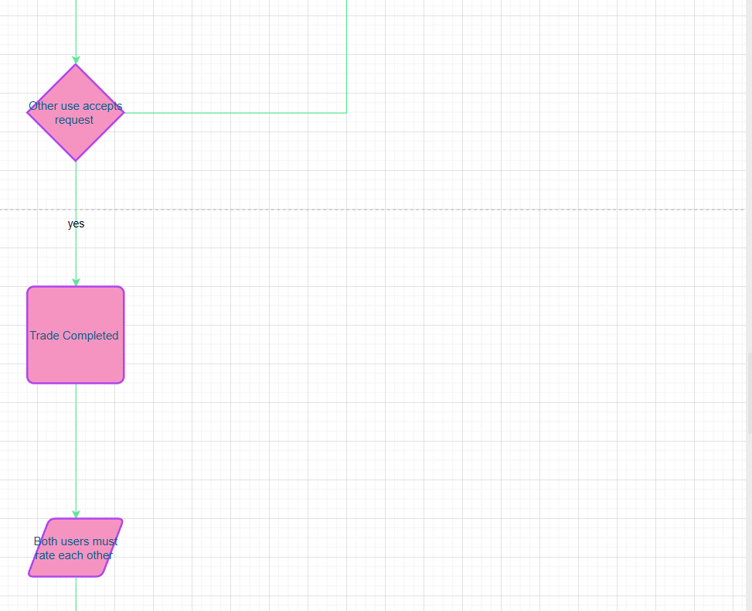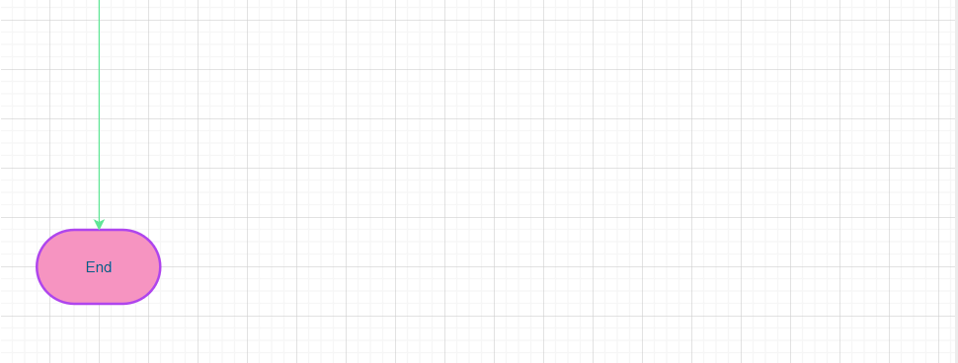

Project Controls
- Use the template to define the risk and list the steps to prevent the risk from occurring or the steps to minimize the chances of it happening. The contingency plan describes alternative solutions to reduce the impact of the risk. An example of a contingency plan is to provide the customer a temporary web server if there are delays in delivery/completion. If the risk has already happened then provide an entry in the issue log.

Risk Management
 | Risk Probability | Risk Impact
Event Risk | (high, medium, low) |  | Risk Mitigation | Contingency Plan
What is the risk? | What is the probability? | What is the impact if the risk occurs? | What can be done to minimize the risk? | What can be done to minimize the impact of the risk?
Trust Between Users | medium | Many users will not trade due to the risk between strangers | Have a trust metric for users to fulfill and be able to trust others | Have this trust metric as a requirement for all users
Location Permission | low | Without location trading with those nearby would be difficult | Make location permission mandatory, a user cannot register unless it is granted | Make sure users are all able to access location and there are no issues
User Experience | medium | There is a multitude of marketplace platforms having a unique and organized app is critical to gaining users | Create a design that is pleasing and easy to use | Make sure the app is visually pleasing and can be used by anyone
Dispute Between users | high | Individuals who do not find something fair or do not agree on something can cause disputes and inappropriate behavior | Add a rating system where after every trade you rate the individual or can report the user if needed | With rating the individual after a trade others can be warned and a report we review can be made for any inappropriate situation

Issues Log
ID | Description | Project Impact | Action Plan/Resolution | Owner | Importance | Date Entered | Date to Review | Date Resolved
1 | What is the issue? | How will this impact scope, schedule & cost? | How do you intend to deal with this issue? | Who manages this issue?
2 | Geolocation: I was unable to add a location and filter/ limit registration for denied location | This will impact the schedule as I now have to focus more on this aspect. | I plan on using any resources available to try and solve this, whether it is learning a new way or updating the way now. | Ana Arellano | High | 3/16/26 | 3/17/26 | 3/22/26 and 4/10/26
3 | Images: I cannot add more than one image to the item | This will impact the schedule as I now have to go back and focus on this step. | I plan to try and fix the size issues but pivot to using one image if necessary. | Ana Arellano | Medium | 3/17/26 | 3/17/26 | 3/28/26

- All projects have either anticipated and planned or unexpected changes. Describe any issues in management or change management due to the anticipated and planned or unexpected changes. Use the template to list anticipated and planned or unexpected changes.

Change Control Log
ID | Change Description | Priority | Originator | Date Entered | Date Assigned | Evaluator | Status | Date of Decision | Included in Rev. #
1 | None at this time | N/A | N/A | N/A | N/A | N/A | N/A | N/A | N/A
2
- Use the template to describe how the end user is involved in the software development, if applicable. Include relevant information about meetings, reviews, presentations, etc.
Roles and Responsibilities
Name | Team | Project Role | Responsibility
Ana Arellano Beltran | 1 | Project Owner | Frontend, Backend, Ui/UX Design

Project Cost and Schedule
- Create a spreadsheet of costs related to the scope of the project, with all necessary material and elements required to accomplish it effectively, and the allocated resources. Note: If the project being designed will not require any cost calculations, please state that here.
  - The project will not require any cost.
- Create a project schedule after all project tasks have been defined and prioritized.
- Set a programming schedule by implementing work breakdown and task time estimates. Create a timeline with dates for completion of key components of the project.

Appendix A – References
Access your bible from anywhere. BibleGateway.com: A searchable online Bible in over 150 versions and 50 languages. (n.d.). https://www.biblegateway.com/

